Chapter 7, Problem 5.

Using Fig. 7.85, design a problem to help other students better understand source-free RC circuits.
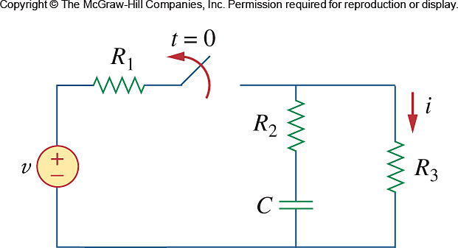

Figure 7.85
For Prob. 7.5.

